**How to open an image in a new tab**

**Introduction**

Opening an image in a new tab can be a simple yet powerful technique when you want to view an image in detail without navigating away from the reading you have opened. This method allows you to enlarge and focus on an image while keeping your document open. This reading will walk you through opening an image in a new tab.

**Why open an image in a new tab?**

Opening an image in a new tab offers several benefits:

* Preserves context: When you open an image in a new tab, the original reading remains accessible. This is particularly useful when you are browsing content where context matters.
* Detailed examination: Some images contain intricate details that might be difficult to appreciate when displayed in a smaller size. Opening an image in a new tab allows you to zoom in and examine these details more closely.
* Ease of navigation: If you are looking at a collection of images, opening them in new tabs can help you navigate them without losing your place on the main page.

**How to open an image in a new tab**

1. Move your cursor over the image you want to open in a new tab.
2. Right-click (or two-finger tap on a trackpad) the image.
3. Select **Open image in new tab** from the dropdown.

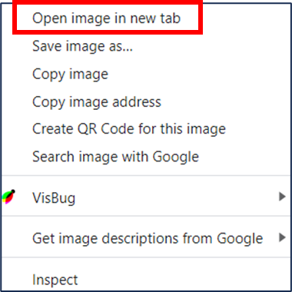

Once you open the image in a new tab, you can view the details more closely, zooming the image if necessary. When you are ready to return to the reading close the image tab or click on the tab that holds your reading.

**Conclusion**

You can quickly open images in new tabs by following these steps. This empowers you to have a more focused and uninterrupted engagement with the images you view.